For this data pipeline, we use the NEX NESM3 model in the SSP585 scenario in the Turkmenistan region for demonstration.

**Step 1: Download data in the format of the NC file for the NEX model.**

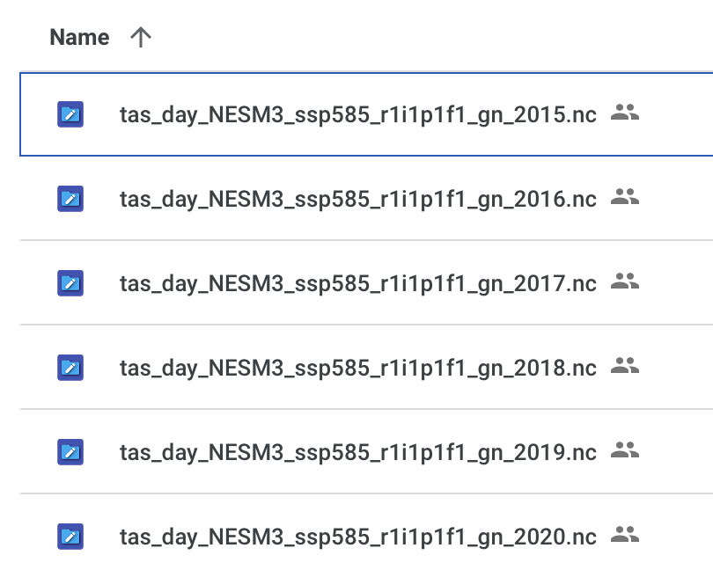

**Step 2: Aggregate the annual data into a 6-years data and transform it to CSV format.**



Code for Step 2(NC to CSV Conversion & Combining CSV): <https://colab.research.google.com/drive/1h9yPXSZD_c29DD49Cq8tApJiqtRmCMXC?usp=share_link>

**Step 3: Download the MODIS data in CSV format for the corresponding region.**



**Step 4: Aggregate daily mean temperature for the NEX model and MODIS.**

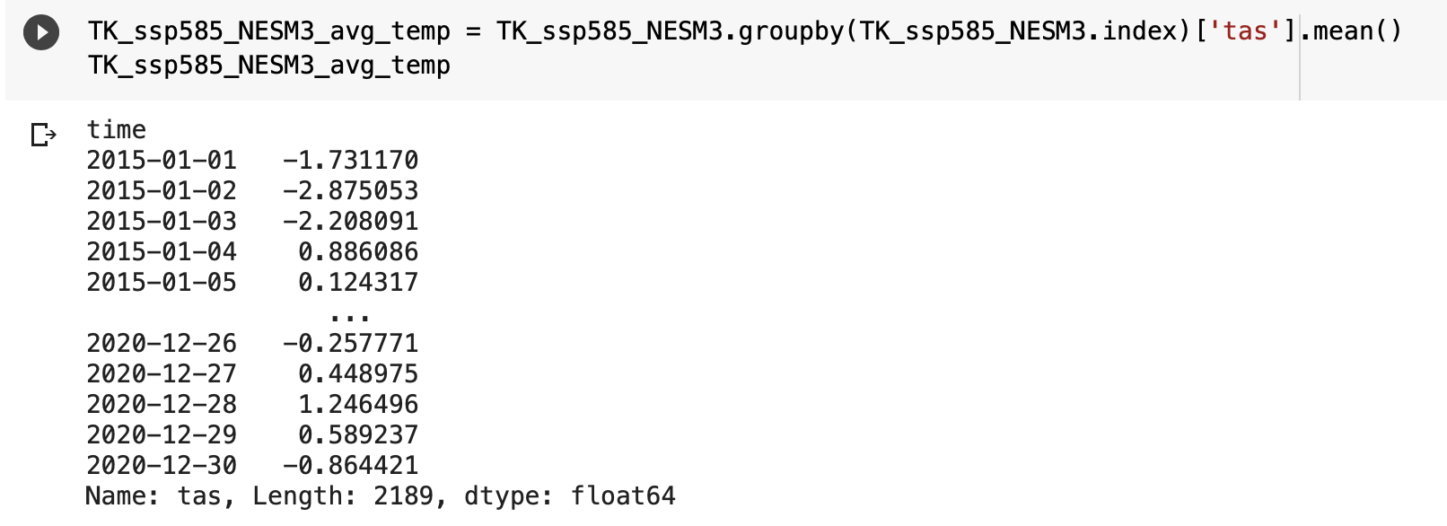

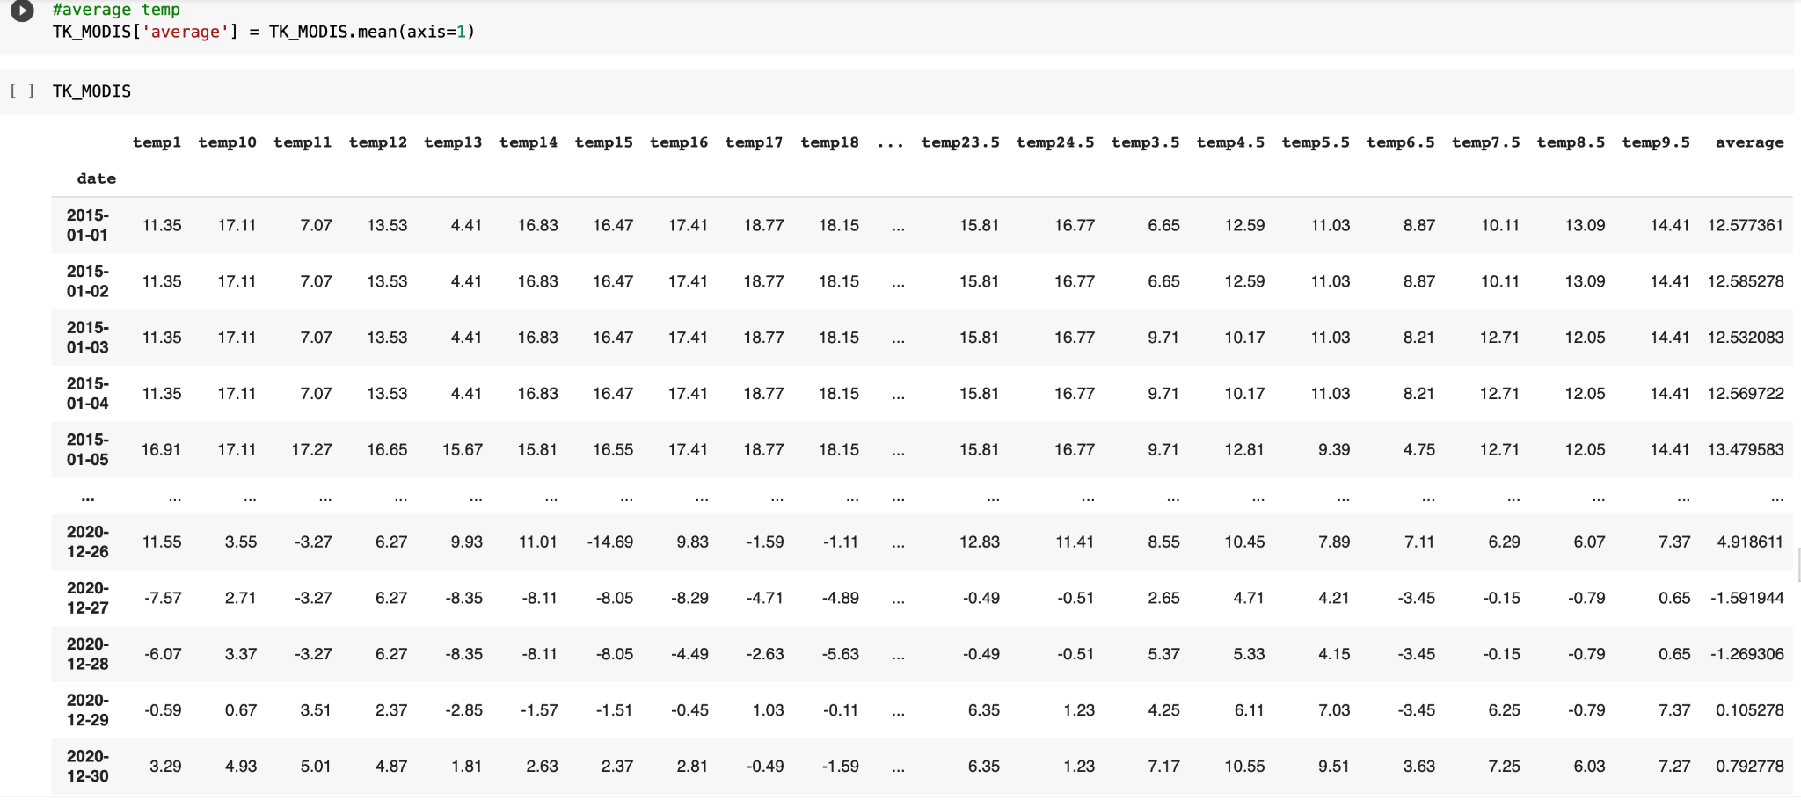

**Step 5: Aggregate monthly mean temperature for the NEX model and MODIS.**

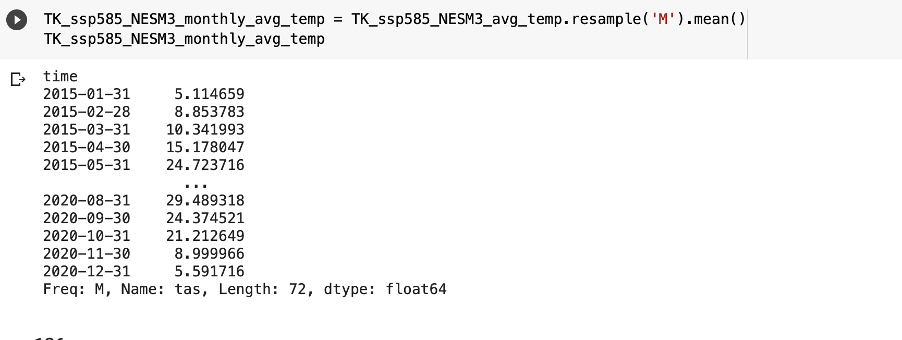

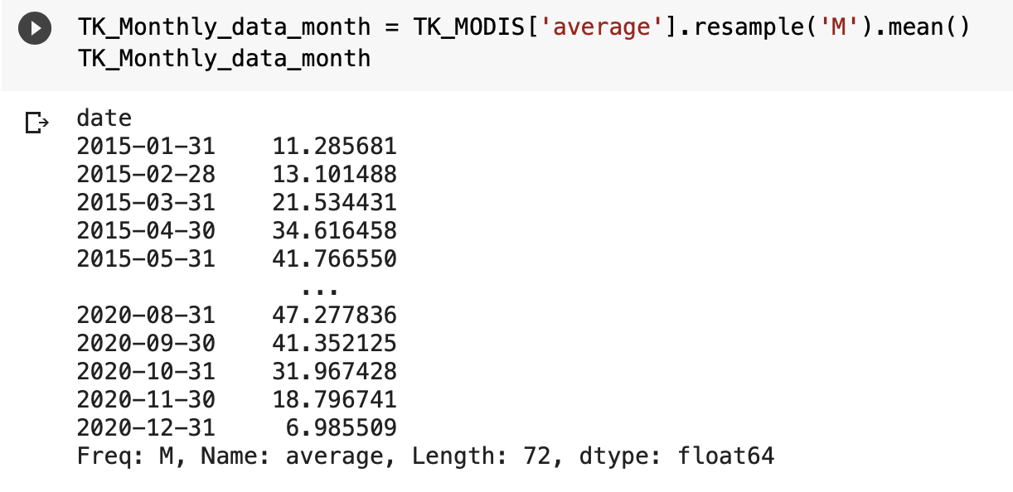

**Step 6: Perform time series decomposition analysis for the NEX model and MODIS.**

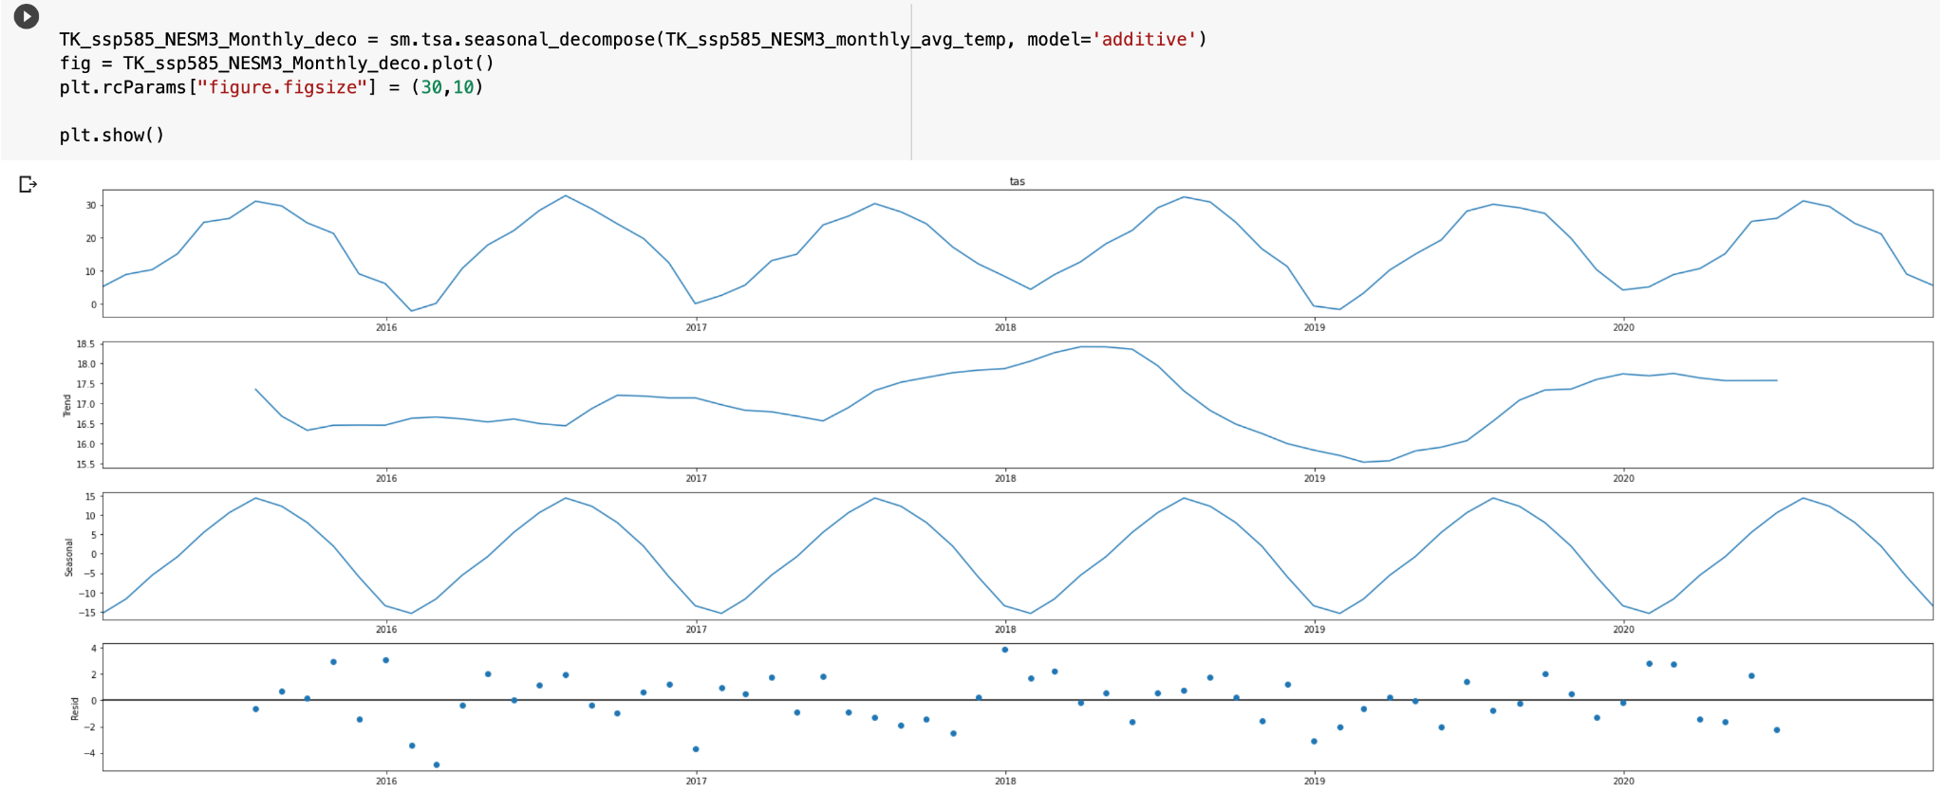

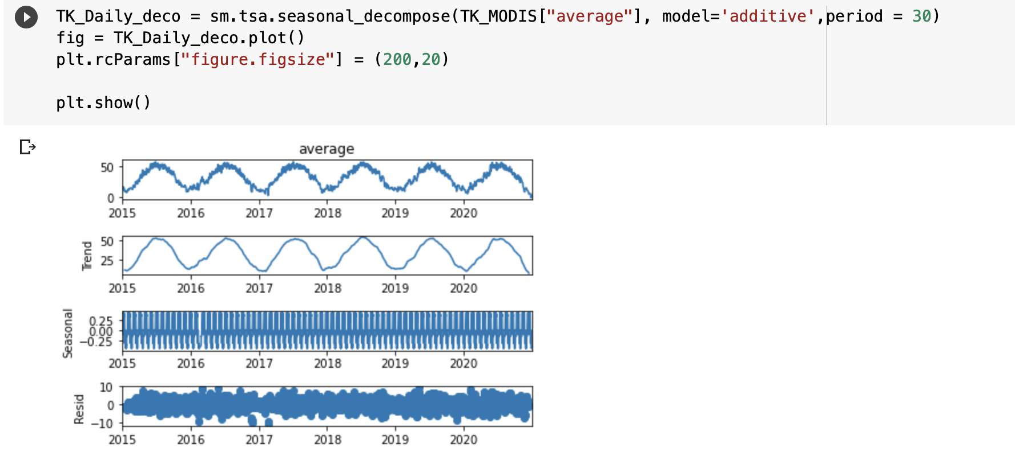

**Step 7: Calculate the RMSE.**

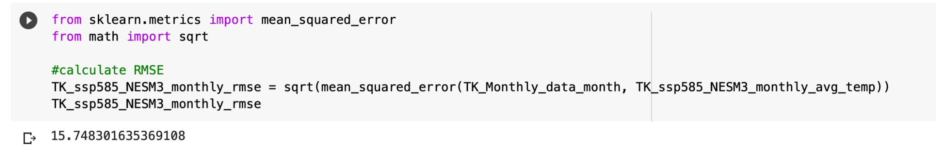

**Step 8: Calculate the R-Square.**

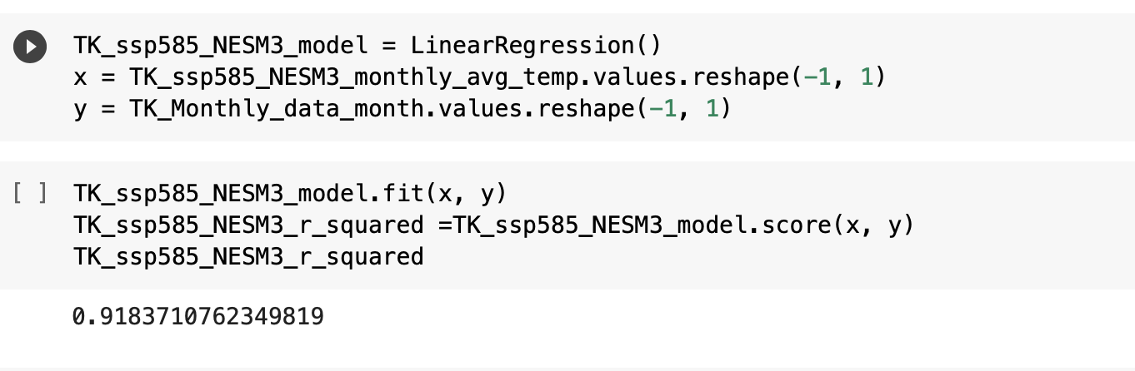

**Step 9: Perform seasonal analysis by dividing annual data into 4 seasons (3 months each) and calculating the coefficients and intercepts.**

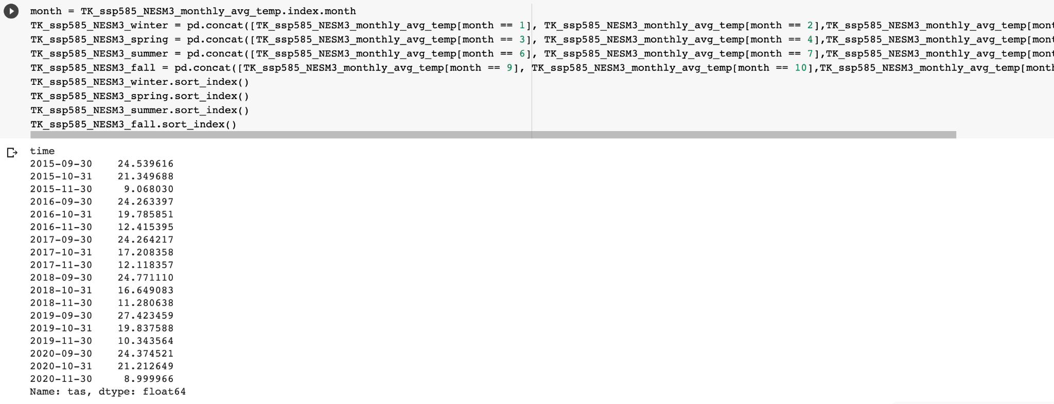

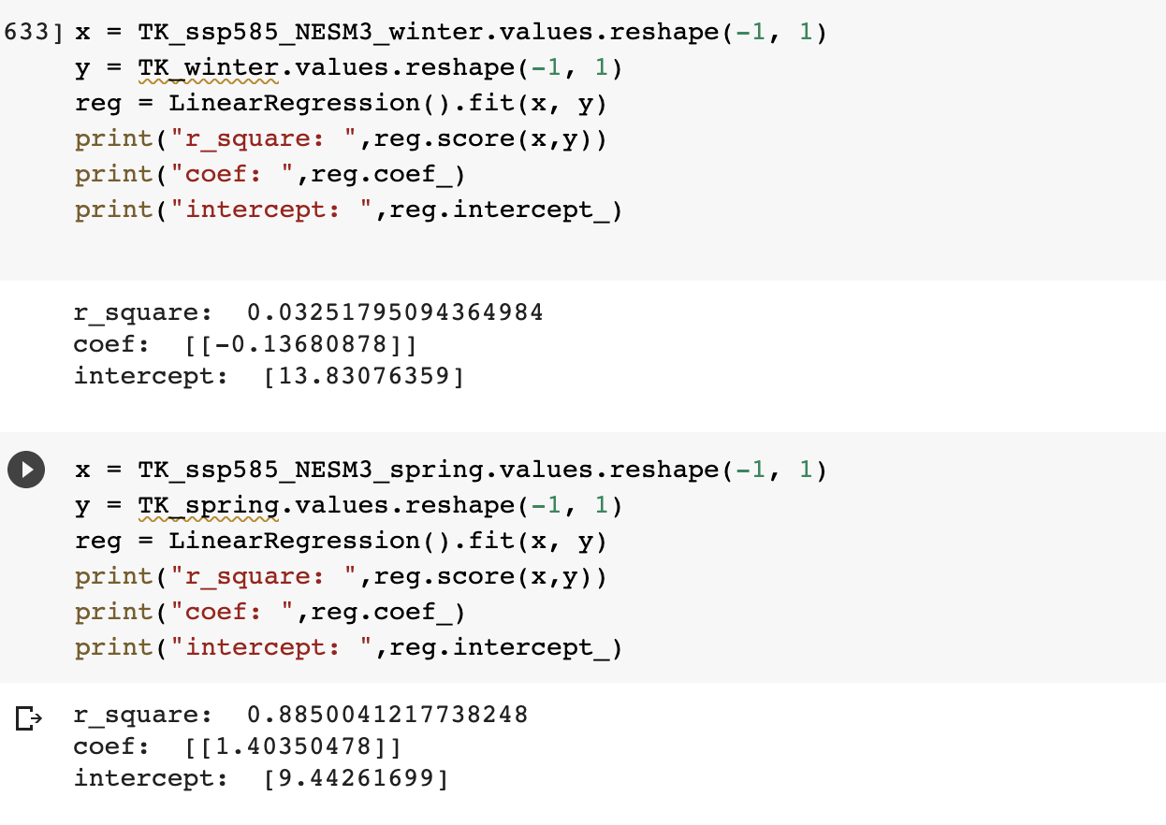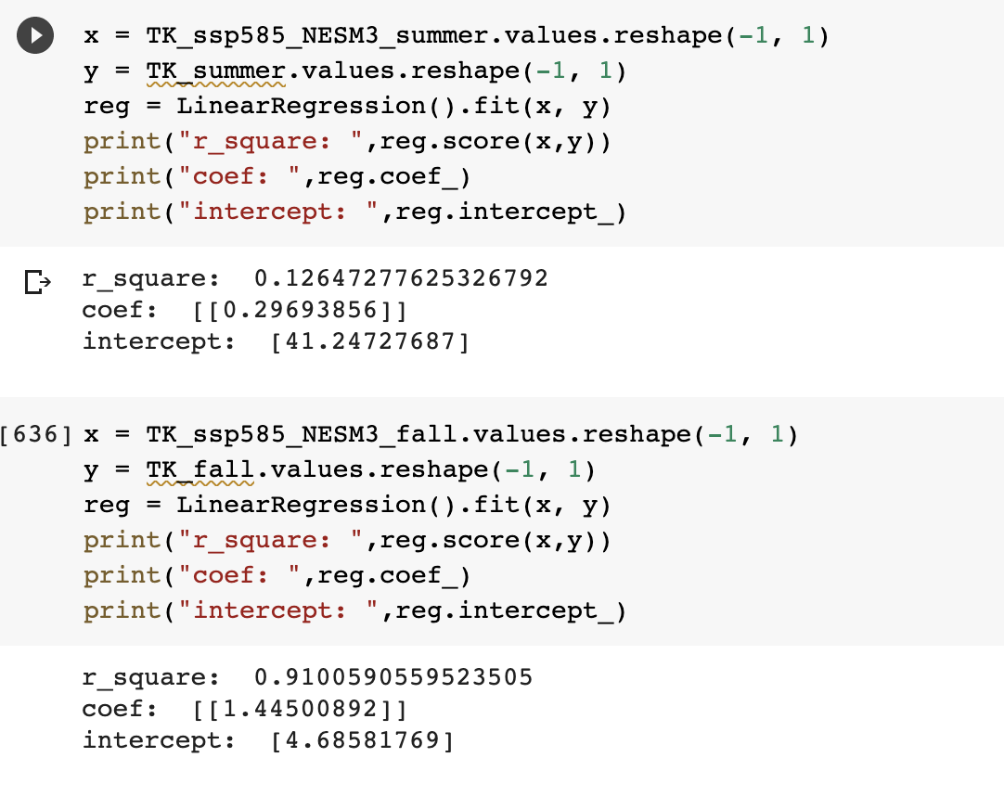

**Step 10: Based on the obtained intercepts from the previous step, calculate the 95% confidence interval for the region.**

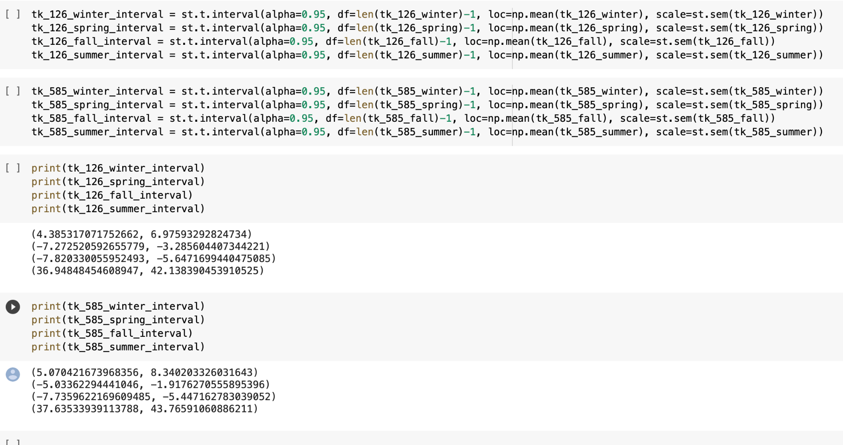

Code for Step 4 to Step 9:

<https://colab.research.google.com/drive/1-DHADGG8oRGwxVBqdYXe8ikqRizEll_g>

Code for Step 10:

<https://colab.research.google.com/drive/1xtLe6NPFLtYp4UAJWmJvXxRqtBCt1xRh?authuser=2#scrollTo=PtMmI51yme2x>